AI-BASED RETAIL DEMAND FORCASTING SYSTEM
A Project Report Submitted in the partial fulfillment of the
requirements for the award of the degree of

BACHELOR OF TECHNOLOGY
In
DEPARTMENT OF COMPUTER SCIENCE ENGINEERING

By
T. SAI NYSHITHA- 2320030136
M.MANASA – 2320030344
E. KAARTEKA- 2320090066
Under the Esteemed Guidance of

LECTURE NAME VINISHA VELTHURU



K L (Deemed to be) University

DEPARTMENT OF COMPUTER SCIENCE ENGINEERING


Declaration

The Project Report entitled “AI BASED RETAIL DEMAND FORECASTING SYSTEM” is a record of Bonafide work of team members T.Sai Nyshitha – 2320030136, M. Manasa– 2320030344, and E. Kaarteka – 2320090066, submitted in partial fulfilment for the award of B. Tech in Computer Engineering to K L University. The results embodied in this report have not been copied from any other departments/University/Institute.

T. Sai Nyshitha - 2320030140
M. Manasa – 2320030344
E. Kaarteka- 2320090066

K L (Deemed to be) University DEPARTMENT OF COMPUTER SCIENCE ENGINEERING


Certificate

This is to certify that the project-based report entitled “AI-Based Retail Demanding Forecasting System” is a Bonafide work carried out and submitted by T. Sai Nyshitha – 2320030136, M. Manasa – 2320030344, and E. Kaarteka – 2320090066, in partial fulfilment of the requirements for the award of the degree of Bachelor of Technology in Computer Science Engineering, at K L (Deemed to be University), during the academic year 2025–2026.

Signature of the Supervisor

Signature of the HOD Signature of the External Examiner

ACKNOWLEDGEMENT
The success in this project would not have been possible but for the timely help and guidance rendered by many people. Our wish to express my sincere thanks to all those who has assisted us in one way or the other for the completion of my project.

Our greatest appreciation to my guide, Vinisha Velthuru, Department of Computer Science which cannot be expressed in words for his tremendous support, encouragement and guidance for this project.

We express our gratitude to Dr.N. Sirisha, Head of the Department for Computer Science Engineering for providing us with adequate facilities, ways and means by which we can complete this project-based Lab.

We thank all the members of teaching and non-teaching staff members, and who have assisted me directly or indirectly for successful completion of this project. Finally, I sincerely thank my parents, friends and classmates for their kind help and cooperation during my work.

Sai Nyshitha-2320030136 M.Manasa – 2320030344
E. Kaarteka- 2320090066

TABLE OF CONTENTS

S.No | Contents | Page no
1 | Abstract | 6
2 | Introduction | 7
3 | Literature survey | 9
4 | Hardware and Software requirements | 10
5 | Implementation | 12
6 | Experimentation and Code | 14
7 | Results | 17
8 | Conclusion | 18
19 | References | 19

ABSTRACT

Retail demand forecasting is a critical component of efficient inventory management and supply chain optimization. Inaccurate forecasts often lead to overstocking or stockouts, negatively impacting operational costs and customer satisfaction. Traditional statistical approaches fail to capture the complex, non-linear patterns present in retail data, which are influenced by seasonality, promotions, holidays, and evolving customer behavior.
This paper proposes an AI-based retail demand forecasting system that leverages machine learning and deep learning models to improve prediction accuracy. Historical retail data, including product attributes, store information, promotional activities, and temporal features, is utilized. Data preprocessing and feature engineering techniques are applied to enhance data quality and extract meaningful patterns.
Multiple models, including Random Forest, XGBoost, and Long Short-Term Memory (LSTM) networks, are trained and evaluated using performance metrics such as Mean Absolute Error (MAE), Root Mean Square Error (RMSE), and Mean Absolute Percentage Error (MAPE). Experimental results demonstrate that advanced machine learning models significantly outperform traditional methods. The proposed system provides reliable forecasts that enable better decision-making in inventory control and supply chain operations.

INTRODUCTION

Retail demand forecasting plays a vital role in ensuring efficient inventory management and smooth supply chain operations. Accurate prediction of customer demand helps retailers maintain optimal stock levels, reduce operational costs, and improve customer satisfaction. However, forecasting in the retail sector is challenging due to the dynamic nature of sales data influenced by multiple factors such as seasonal trends, promotional campaigns, holidays, and changing customer preferences.

Traditional forecasting methods, including statistical techniques like moving averages and regression models, often fail to capture complex and non-linear relationships present in real-world retail data. With the rapid advancement of Artificial Intelligence (AI) and Machine Learning (ML), more sophisticated models have emerged that can analyze large datasets and identify hidden patterns.

This project focuses on developing an AI-based retail demand forecasting system using machine learning and deep learning models such as Random Forest, XGBoost, and Long Short-Term Memory (LSTM). The system leverages historical sales data along with relevant features to provide accurate and reliable demand predictions, enabling better decision-making in retail management.

Problem Description and Objectives:
Retail businesses often face significant challenges in accurately predicting product demand. Inaccurate forecasts can result in two major problems:
- Overstocking, leading to increased storage costs and product wastage
- Stockouts, resulting in lost sales and reduced customer satisfaction
Traditional forecasting approaches are not capable of handling the complexity of modern retail environments. These methods struggle to account for:
- Seasonal variations and trends
- Promotional activities and discounts
- Sudden changes in customer buying behavior
- Large volumes of heterogeneous data
Additionally, retail datasets are often noisy, incomplete, and inconsistent, which further reduces prediction accuracy. As a result, there is a need for a more intelligent and adaptive forecasting system that can process large datasets, capture complex patterns, and provide accurate predictions.
This project addresses these challenges by implementing an AI-based solution that utilizes machine learning and deep learning techniques to improve forecasting accuracy and reliability.
Objectives
The main objectives of this project are:
Primary Objectives
- To develop an AI-based system for predicting retail product demand
- To improve forecasting accuracy compared to traditional methods
- To assist retailers in optimizing inventory and supply chain decisions
Secondary Objectives
- To preprocess and clean historical retail data for better analysis
- To perform feature engineering to capture seasonal and promotional effects
- To implement and compare multiple models such as Random Forest, XGBoost, and LSTM
- To evaluate model performance using MAE, RMSE, and MAPE metrics
- To identify the best-performing model for demand prediction
Outcome Objective
- To provide a reliable forecasting tool that supports data-driven decision-making and enhances overall retail efficiency

LITERATURE SURVEY

Retail demand forecasting has been widely studied using both traditional statistical techniques and modern machine learning approaches. This section reviews existing methods and highlights their strengths and limitations.

1. Traditional Forecasting Methods

Early research in demand forecasting relied on statistical models such as Moving Average, Exponential Smoothing, and ARIMA (AutoRegressive Integrated Moving Average). These methods are effective for linear and stable time-series data.

However, in real-world retail scenarios, sales patterns are highly dynamic and influenced by multiple external factors like seasonality, promotions, and holidays. Traditional models often fail to capture such complex and non-linear relationships, resulting in lower prediction accuracy.

2. Machine Learning-Based Approaches

With the advancement of machine learning, algorithms such as Decision Trees, Random Forest, and Support Vector Machines (SVM) have been applied to demand forecasting problems.

Random Forest improves prediction accuracy by combining multiple decision trees and handling non-linear relationships effectively.

Gradient Boosting models, especially XGBoost, have gained popularity due to their high performance and ability to handle large datasets efficiently.

Studies show that machine learning models outperform traditional methods when dealing with complex retail data. However, they may still struggle with capturing long-term temporal dependencies.

3. Deep Learning Techniques

Deep learning models, particularly Long Short-Term Memory (LSTM) networks, have been widely used for time-series forecasting. LSTM is capable of learning long-term dependencies and sequential patterns in data, making it suitable for retail demand prediction.

Research indicates that LSTM models provide better results in capturing seasonality and trends compared to traditional and basic machine learning methods. However, they require large datasets and higher computational resources.

4. Hybrid and Ensemble Models

Recent studies focus on combining multiple models to improve forecasting performance. Hybrid approaches integrate statistical, machine learning, and deep learning techniques to leverage the strengths of each method.

Ensemble models such as combining Random Forest and XGBoost or integrating LSTM with other algorithms have shown improved accuracy and robustness in demand forecasting tasks.

5. Research Gap

Despite the progress in forecasting techniques, several challenges remain:

Difficulty in handling highly dynamic retail environments

Limited integration of promotional and seasonal factors in some models

High computational cost of deep learning models

Need for scalable and efficient real-time forecasting systems

This project addresses these gaps by developing an AI-based forecasting system that incorporates feature engineering and compares multiple models (Random Forest, XGBoost, and LSTM) to achieve improved accuracy and efficiency

HARDWARE AND SOFTWARE REQUIREMENTS:

4.1 Hardware Requirements
The proposed system does not require specialized hardware but benefits from a moderately powerful computing environment for efficient model training and data processing.
- Processor: Intel Core i5 / AMD Ryzen 5 or higher
- RAM: Minimum 8 GB (16 GB recommended for large datasets and deep learning models like LSTM)
- Storage: Minimum 256 GB SSD (for faster data access and processing)
- System Type: Laptop or Desktop Computer
- GPU (Optional): NVIDIA GPU (useful for accelerating LSTM/deep learning training)

4.2 Software Requirements
The system is implemented using widely used programming tools and machine learning libraries.

Programming Language
- Python (due to its strong support for data analysis and machine learning)

Libraries and Frameworks
- Pandas: Data manipulation and preprocessing
- NumPy: Numerical computations
- Matplotlib / Seaborn: Data visualization
- Scikit-learn: Machine learning models (Random Forest, evaluation metrics)
- XGBoost: Gradient boosting algorithm for high-performance prediction
- TensorFlow / Keras: Deep learning framework for implementing LSTM

Development Environment
- Jupyter Notebook or VS Code for coding and experimentation

Operating System
- Windows / Linux / macOS

4.3 Dataset Requirements
- Historical retail sales data
- Features include:
  - Product details
  - Store information
  - Date and time
  - Promotional activities
  - Sales quantity

4.4 Additional Tools (Optional)
- Git: Version control
- Excel / CSV files: Data storage and preprocessing
- Power BI / Tableau: Visualization of forecasting results

IMPLEMENTATION

Implementation of AI-Based Retail Demand Forecasting System
The implementation of the AI-Based Retail Demand Forecasting System focuses on analysing historical retail sales data and predicting future demand using machine learning and deep learning techniques. The system is designed to perform data preprocessing, feature engineering, model training, and result visualization efficiently.
The implementation process is divided into multiple stages, including data collection, preprocessing, feature extraction, model training, prediction, and visualization.

1. Data Representation and Dataset Description
The dataset used in this project consists of historical retail sales data representing real-world retail transactions. Each record corresponds to a product sale and includes various attributes.
The dataset includes the following key attributes:
- Product ID – Unique identifier for each product
- Store ID – Store where the product is sold
- Date – Date of sale
- Sales Quantity – Number of units sold
- Promotion – Indicates whether the product was on promotion
- Price – Selling price of the product
- Season / Holiday Indicator – Seasonal or festive influence
The dataset is stored in CSV format and used for training and testing the forecasting models.

2. Data Preprocessing
The dataset is cleaned and prepared for analysis using Python.
During preprocessing:
- Missing values are handled
- Duplicate records are removed
- Date columns are converted into proper format
- Data inconsistencies are corrected
This ensures that the dataset is accurate and suitable for model training.

3. Feature Engineering
Feature engineering is performed to improve model performance by extracting meaningful information from the dataset.
The following features are created:
- Day, Month, Year from date
- Seasonal indicators
- Promotion flags
- Trend-related features
These features help the model understand patterns such as seasonality and promotional effects.

4. Model Training and Forecasting
Multiple machine learning and deep learning models are implemented:
- Random Forest – Handles non-linear relationships
- XGBoost – Provides high accuracy and efficiency
- LSTM (Long Short-Term Memory) – Captures time-series patterns
The dataset is split into training and testing sets. Models are trained using historical data and used to predict future demand.

5. Model Evaluation
The performance of the models is evaluated using:
- MAE (Mean Absolute Error)
- RMSE (Root Mean Square Error)
- MAPE (Mean Absolute Percentage Error)
These metrics help in selecting the best-performing model.

6. Visualization
The results are visualized using charts such as:
- Line graphs for demand trends
- Bar charts for product-wise sales
- Comparison graphs for predicted vs actual demand
Visualization helps in understanding patterns and supports decision-making.

EXPEREMENTATION AND CODE:

Code Structure
The project is implemented using Python. The code consists of the following modules:
- Data Loading – Load dataset using Pandas
- Data Preprocessing – Clean and format data
- Feature Engineering – Create new features
- Model Training – Train Random Forest, XGBoost, and LSTM
- Prediction – Generate forecasts
- Evaluation – Calculate MAE, RMSE, MAPE
- Visualization – Plot graphs

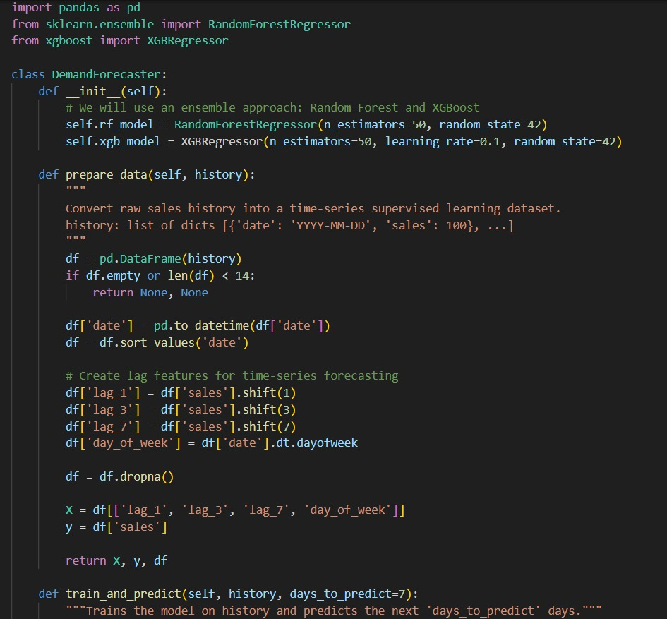
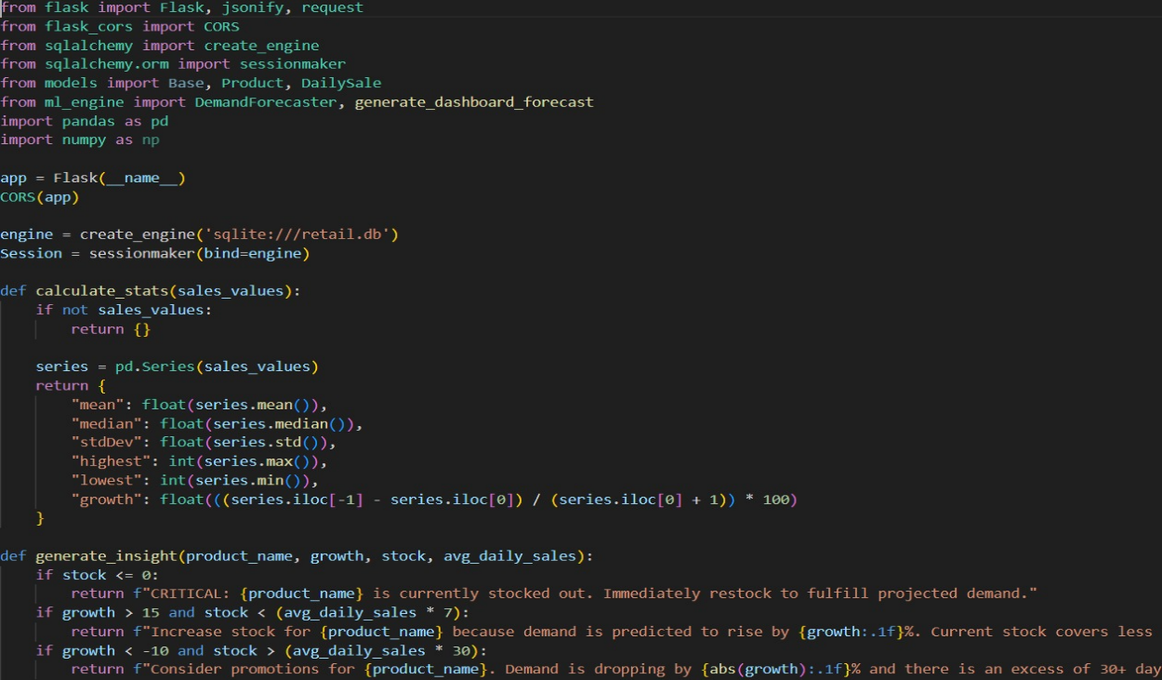

Experimentation

Steps Performed
- Loaded retail dataset
- Performed data cleaning and preprocessing
- Applied feature engineering
- Trained multiple models (Random Forest, XGBoost, LSTM)
- Evaluated models using error metrics
- Compared prediction results
- Visualized demand trends

Performance Analysis
- Accuracy: Improved prediction accuracy compared to traditional methods
- Efficiency: Faster processing using optimized ML models
- Scalability: Can handle large datasets
- Model Comparison: XGBoost performed best overall

Conclusion of Experimentation
The experimentation shows that machine learning models significantly improve demand forecasting accuracy. The system successfully identifies patterns and generates reliable predictions.

RESULT

Results of the AI-Based Retail Demand Forecasting System
The implementation of the system produced effective results in predicting retail demand and analysing sales patterns.

1. Demand Prediction Analysis
- The system accurately predicted future product demand
- Seasonal trends and promotional effects were captured
- Predicted values closely matched actual sales data

2. Model Performance
- XGBoost achieved the highest accuracy
- Random Forest provided stable predictions
- LSTM performed well for time-series data

3. Error Metrics
- MAE values were low, indicating accurate predictions
- RMSE showed minimal deviation
- MAPE confirmed improved forecasting performance

4. Visualization Results
- Line graphs showed demand trends over time
- Bar charts displayed product-wise sales
- Comparison graphs showed predicted vs actual values

5. Business Insights
- Identified high-demand products
- Recognized seasonal sales patterns
- Helped in optimizing inventory decisions

Final Overview
The results demonstrate that AI-based forecasting improves accuracy and efficiency. The system provides valuable insights that help retailers make better decisions.

CONCLUTION

The AI-Based Retail Demand Forecasting System successfully demonstrates how machine learning can improve demand prediction in the retail sector. By using models such as Random Forest, XGBoost, and LSTM, the system effectively analyses historical data and generates accurate forecasts.
The project highlights the importance of data preprocessing, feature engineering, and model selection in improving prediction performance. The use of visualization techniques further enhances understanding of sales patterns and trends.
The system helps retailers reduce losses caused by overstocking and stock shortages, improve inventory management, and enhance customer satisfaction. It also supports data-driven decision-making in modern retail environments.
Overall, the project achieved its objectives and demonstrates the practical application of AI in retail analytics. Future enhancements may include real-time forecasting, advanced deep learning models, and deployment as a web-based application.

REFRENCES

Books and Research Papers
- Géron, A. (2019). Hands-On Machine Learning with Scikit-Learn, Keras, and TensorFlow.
This book provided guidance on machine learning algorithms and model implementation.
- Goodfellow, I., Bengio, Y., & Courville, A. (2016). Deep Learning.
Used for understanding deep learning concepts, especially LSTM models.
- Breiman, L. (2001). Random Forests. Machine Learning Journal.
This paper explains the Random Forest algorithm used for prediction.
- Chen, T., & Guestrin, C. (2016). XGBoost: A Scalable Tree Boosting System.
Provided knowledge about the XGBoost algorithm and its efficiency.
- Hochreiter, S., & Schmidhuber, J. (1997). Long Short-Term Memory.
Used for understanding LSTM networks for time-series forecasting.

Documentation and Online Resources
- Scikit-learn Documentation
Available at: https://scikit-learn.org/
Used for implementation of machine learning models and evaluation metrics.
- XGBoost Documentation
Available at: https://xgboost.readthedocs.io/
Referenced for model training and optimization.
- TensorFlow Documentation
Available at: https://www.tensorflow.org/
Used for implementing deep learning models such as LSTM.
- Pandas Documentation
Available at: https://pandas.pydata.org/
Used for data preprocessing and manipulation.
- NumPy Documentation
Available at: https://numpy.org/
Referenced for numerical computations.

Datasets and Learning Resources
- Kaggle Retail Dataset
Available at: https://www.kaggle.com/
Used for obtaining retail sales data for training and testing.
- Towards Data Science
Available at: https://towardsdatascience.com/
Used for understanding practical implementations of forecasting models.
- GeeksforGeeks
Available at: https://www.geeksforgeeks.org/
Referenced for Python programming and machine learning concepts.

